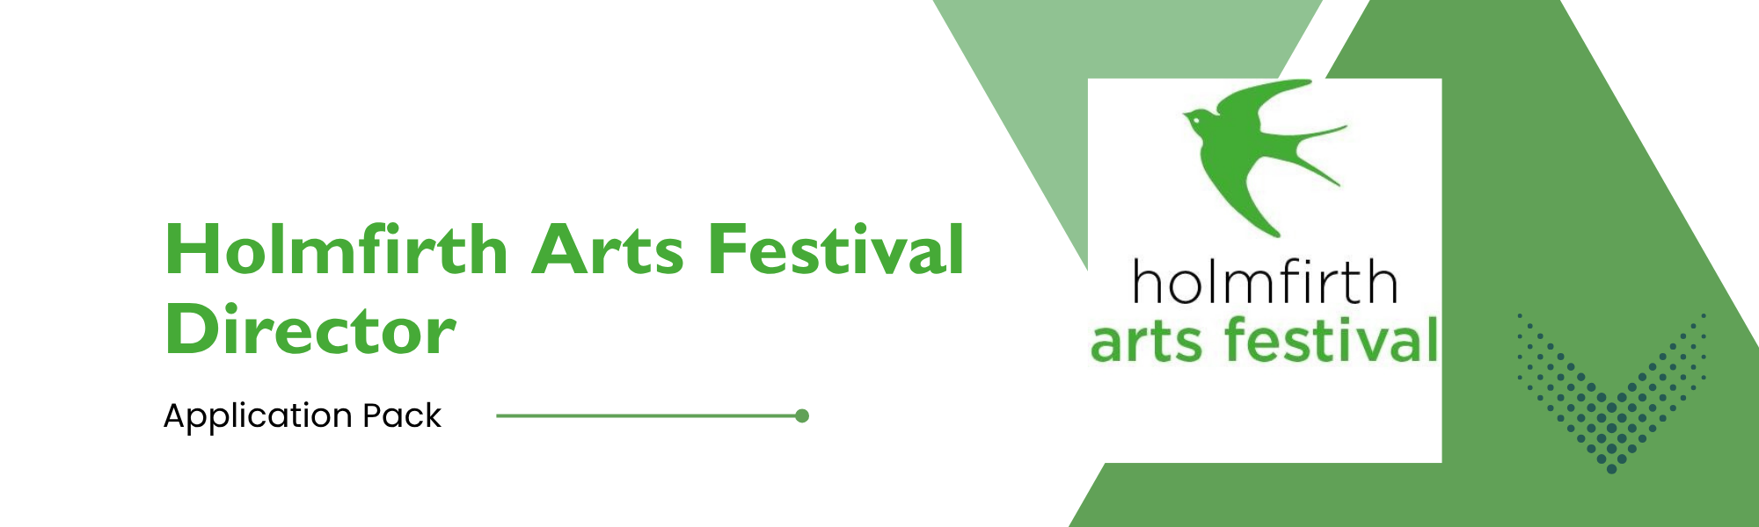
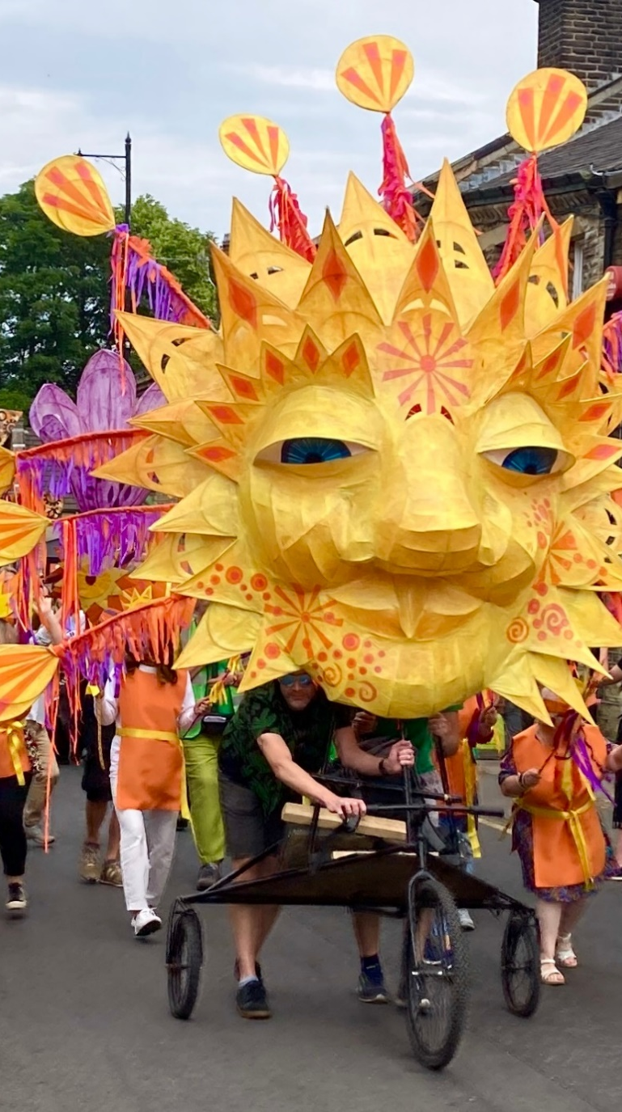  Image: Handmade Parade at Holmfirth Arts Festival 2023 | Contents  1. The Advertisement  2. Job Description  3. The Personal Specification  4. Safer Recruitment Form  5. Equal opportunities Form
Director, Holmfirth Arts Festival
We’re looking for a creative, energetic arts professional with strong experience of fundraising, programming and managing festivals to take over directorship of the Holmfirth Arts Festival, following many successful festivals under the direction of Bev Adams.
Holmfirth Arts Festival is a celebration of music, art, comedy, theatre, literature and inspiring things to do in the market town of Holmfirth and the surrounding Holme Valley. It reflects the character and history of the area, with a unique local resonance, while being ground-breaking and ambitious, so this is a great opportunity to build a local festival of regional and national significance.
The board see this as an excellent opportunity for the new director to embrace the wide variety of grassroots talent within the valley and seek a new direction for the festival, by building connections with the broad range of businesses in the town. Creating a festival that celebrates the local heritage as well as the emerging artists of the Holmfirth area.
You will have strong programming and project management experience, fundraising experience (including from Arts Council England/ Heritage Lottery Fund and Trusts/ Foundations, as well as sponsorship), a history of sound budget management and a good understanding of audience development. You’ll also be able to work on your own initiative as well as with a board and volunteers.
This is a freelance contract for an initial 24 days at £250/day (£6K) to enable handover and fundraising for the 2027 festival. Thereafter, we intend to offer a further freelance contract based on an annual fee of c.£22,500, tbc based on an estimated 90 days per year at £250 per day, subject to funding being available.
You can download the job pack from our homepage at www.holmfirthartsfestival.co.uk. Further information about past festivals can be found here https://www.holmfirthartsfestival.co.uk/previous-festivals and additional information is available by emailing Jan Ansell/ Kate Buchanan trustees@holmfirthartsfestival.co.uk
Please reply responding to the advert and person specification with a covering letter, or a short video, detailing your relevant knowledge and experience. Please also attach a CV and complete and attach the safer recruitment and diversity and inclusion forms.
Please email trustees@holmfirthartsfestival.co.uk by 5.00pm on Friday 1st May.

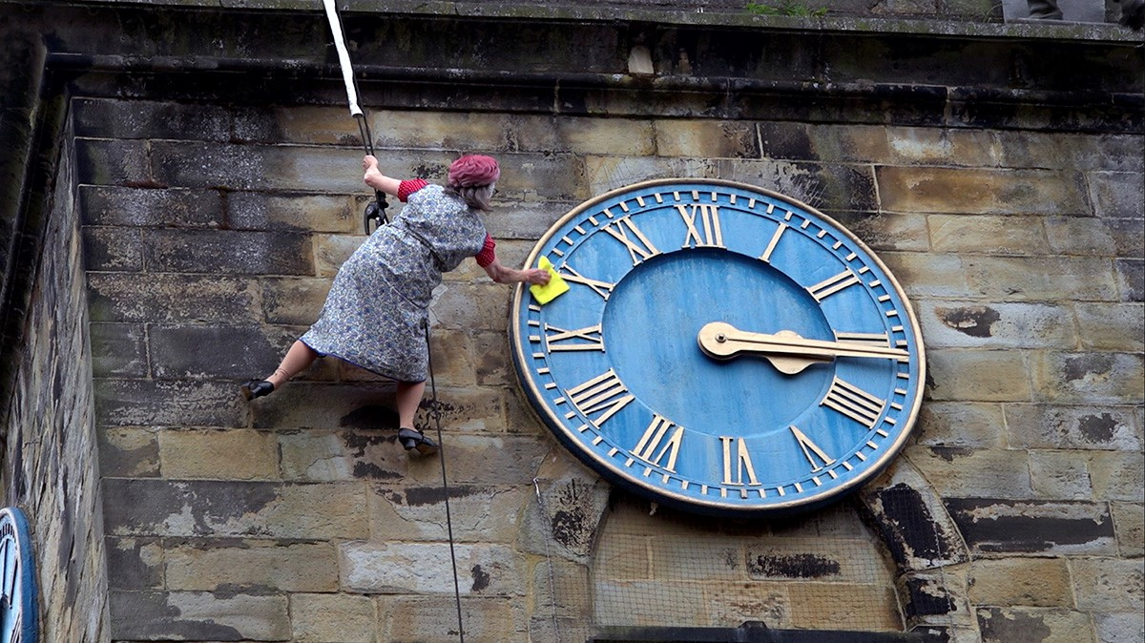
Job Description and Person Specification
Image: Flyin’ Compo and Flamin’ Nora by Urban Angels Circus at Holmfirth Arts Festival 2024. Photo by John Coombes
Job Description
Purposes of the Festival
- To create an outstanding annual cultural event in and around Holmfirth
- To continue and develop the festival’s commitment to commissioning new work and to explore the potential for this work to have a life beyond Holmfirth, through touring and partnerships with other festivals
- To encourage more people to participate in and enjoy the arts in an area away from existing mainstream arts venues and provide access to high quality arts activity for the whole community
- To celebrate Holmfirth, its stories and its communities through a programme that is rooted but transformative
- To encourage and support visitors to Holmfirth
Main Duties of the Festival Director
- To provide vision and leadership in planning and delivering an outstanding festival, in and around Holmfirth
- To include the commissioning of new work in the festival, and to explore the partnership and touring potential for this work
- To work closely with other festivals, developing joint projects and programmes as required and to create new audiences for the Festival’s output
- To lead the festival’s fundraising activities, working with the Board, and in particular to prepare an application to Arts Council England’s Grants for the Arts programme to enable the delivery of the festival in 2027 and beyond
- To develop partnerships and stakeholders, including local schools and community groups
- To manage the festival budget, with the Treasurer
- To work effectively with the board, providing advice, attending board meetings and writing reports for the Board, as required
- To help recruit and manage a volunteer festival team
- To recruit and manage freelance staff as required (usually seasonally).
This role will require the post-holder to be fully self-supporting administratively.
(NB. We would like the new post holder to be available for our Big Weekend event on 13th & 14th June followed by a hand over period in July)
Accountable to: The Chair and the Board of Holmfirth Arts and Music Ltd (Holmfirth Arts Festival)
Responsible for: Any freelance contractors that may be engaged, Festival Manager, Access and Inclusion manager in agreement with the Board.

Person Specification
 | Essential | Desirable
Qualifications | - | Degree level education in any relevant subject
Knowledge and skills | Strong network of contacts within the arts and cultural sectors  Understanding of festival life cycles  Marketing and audience development  Budget management  Excellent organisational and time management skills  Excellent writing ability  Strong negotiating skills  Confident communication skills  Full driving licence | Knowledge of computerised Box Office systems  Website management
Experience | Managing festivals  Commissioning and producing new work  Programming  Project management  Developing and writing funding bids, esp to Arts Council England  Working with a board  Working effectively with volunteers  Working on your own initiative and as part of a team  Working with children and young people  Proven track record of fundraising  Being fully self-supporting administratively  Recruitment, management and leadership of staff and freelance contractors | Dealing with the public  Updating Wordpress websites
Personal attributes | Creative and energetic  Positive and empathetic  Tactful and diplomatic  Punctual and reliable  Able to work well under pressure  Able to be flexible and work evenings and weekends where required.

Safer Recruitment Form
Festival Director
This form is designed to support safer recruitment practices for the role of Festival Director. Please complete all sections thoroughly. All information will be treated in strict confidence.
Personal Details
Full Name
Address
Postcode
Telephone
Email

Employment History
Please provide details of your employment history, starting with your most recent position. Include any gaps in employment and the reasons for them.
Employer | Position | Dates (From - To) | Reason for Leaving

Qualifications & Training
List all relevant qualifications, training, and professional development.
Qualification/Training | Institution/Provider | Date Achieved

References
Please provide details of two referees, one of whom should be your current or most recent employer. References will not be contacted without your permission.
Name
Relationship
Organisation
Contact Details

Name
Relationship
Organisation
Contact Details
Disclosure and Safeguarding
Have you ever been convicted of a criminal offence, cautioned, or are you currently under investigation? (Please provide details, or state 'None')
___________________________________________________________________
Are you barred from working with children or vulnerable adults? (Yes/No) ________
Please declare any relationships with existing staff, trustees, or board members:
___________________________________________________________________
Declaration
I declare that the information given in this form is true and complete. I understand that any false statements may lead to the withdrawal of an offer or dismissal.
Signature: ___________________________ Date: _______________

Inclusion, Diversity, Equity and Access (IDEA) Monitoring Form
Please complete this form to help us ensure our recruitment process is fair and accessible. This information will be kept confidential and used for monitoring purposes only. It will not be used to make decisions about your application.
Personal Details
Name: ___________________________________
Position applied for: Festival Director

Gender
☐ Male
☐ Female
☐ Non-binary
☐ Prefer to self-describe: ____________________
☐ Prefer not to say
Age Group
☐ Under 18
☐ 18–24
☐ 25–34
☐ 35–44
☐ 45–54
☐ 55–64
☐ 65 or over
☐ Prefer not to say

Ethnic Group
☐ White
☐ Irish Traveller
☐ Black or Black British
☐ Asian or Asian British
☐ Mixed / Multiple ethnic groups
☐ Other ethnic group: ____________________
☐ Prefer not to say

Disability
Do you consider yourself to have a disability or long-term health condition?
☐ Yes
☐ No
☐ Prefer not to say

Religion or Belief
☐ Christian (including Church of England, Catholic, Protestant, and all other denominations)
☐ Buddhist
☐ Hindu
☐ Jewish
☐ Muslim
☐ Sikh
☐ No religion
☐ Other (please specify): ____________________
☐ Prefer not to say

Sexual Orientation
☐ Heterosexual / Straight
☐ Gay / Lesbian
☐ Bisexual
☐ Prefer to self-describe: ____________________
☐ Prefer not to say
Thank you for taking the time to complete this form. Your responses will help us to ensure that we are offering equal opportunities for all applicants.

